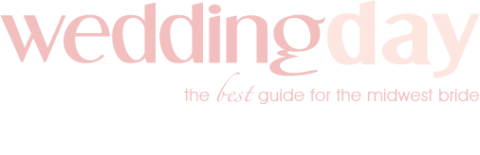

Style Shoot Questionnaire

Tell us a little about the vision for this shoot.

Why did you choose the theme you selected?

How did you incorporate the Pantone Color of the Year?

What difficulties did you have in pulling off this shoot?

Do you have a name for the style concept?

Did you make an effort to include any hot trends into this style shoot?

Why did you choose this location for the venue? How does the style of the venue complement the shoot? Did the venue present any challenges?

How did the wedding dress align with your style shoot? How was it selected? Describe the dress and how the style was worked into the shoot. Please provide the designer and style name if you know it.

What flowers were used in the bouquets and decor? Any particular reason why?

Tell us about the hair and makeup on the bride. How was her hair done? What makeup and colors were used?

Did you give a vision to the stationery company about what you wanted for the stationery? What was their inspiration?

Describe the cake/desserts.

What decor rentals did you use? How did they help with the vision and execution of the shoot?

Form filled out by:

