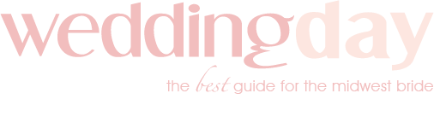

Style Shoot Questionnaire

Tell me a little about the vision for this shoot. Whose idea was it? What were you picturing in your heart?

What difficulties did you have in pulling off this shoot?

Do you have a name for the style concept?

Why did you choose this location for the venue? Did the venue present any challenges?

Describe the allure of this venue and how it fit into the style you were going for?

How did the wedding dress align with your style shoot? How was it selected? Please describe the dress and how the style was worked into the shoot.

What flowers were used in the bouquets and decor? Any particular reason why?

What made you select this particular color palette?

Tell us about the hair and makeup on the bride. How was her hair done? What makeup and colors were used?

Did you give a vision to the stationery company about what you wanted for the stationery? What was their inspiration?

Describe the cake/desserts.

What decor rentals did you use? How did they help with the vision and execution of the shoot?

Did you make an effort to include any hot trends into this style shoot?

